# Restaurant Automation Requirements

|  |  |  |  |  |
| --- | --- | --- | --- | --- |
| Project : | Restaurant Automation |  |  |  |
| First name | Surname | ID | Email |  |
|  |  |  |  |  |
| Himanshu | Shah | 1896502 | himanshushah96@gmail.com |  |
| Urvil | Shah | 1896494 | urvilshah56@gmail.com |  |
| Harshil | Ramswaroop | 1896362 | hramswaroop@gmail.com |  |
| Avtar | Singh | 1896909 | av.avtargill@gmail.com |  |
| Amardeep | Kaur | 1895889 | annukaur25101992@gmail.com |  |
|  |  |  |  |  |

# 

# Client Requirement

Introduction : RESTAURANT Automation Application: The CEGEP Gim system wants to develop an app for Restaurants. In this the Restaurant Manager wants to manage the crowd and order food for dining in and takeout. Users can book a table in a restaurant and as well as users can see there are tables available or not. The user can order food from the table using the application so the manager does not need to hire more staff. The chef can see the order directly in the application with the table number. Users can see restaurant status like Restaurant full book with average waiting time, available space(Table). Users can see the menu in application and order food. After food order users can see bill summary and pay bills in cash (at the counter) or pay by Credit card. Give a feasible solution for the restaurant so Customer, Chef, Cashier and manager can use the application. Users will get a notification of the available table and the chef also gets notification of order.

# Primary Users

1. Customer
2. Manager
3. Cashier
4. Chef
5. Admin

# Requirements :

* Customer Roles

1. Able to create an account(Register).
2. Able to login using email and password.
3. Will have an option to recover password
4. Will have the option to change password.
5. Can register into an application by providing following details
   1. Name
   2. Email
   3. Password
   4. Phone no.
6. Can reserve a table for a particular number of people.(If the table is not available, you can see the average waiting time for a table).
7. Can reserve more than one table , maximum 2.
8. Can add multiple menu items to the cart.
9. Select payment option through a card or at the counter.
10. Options Dine in or Takeout.
11. Gets notification of the available table.
12. Delete the account.
13. Logout of the account.
14. Give feedback/review.

* Manager Roles

1. Can login to the app using email and password
2. Can change the password
3. Add an employee. As per the role.
4. See the status of all the tables (reserved and available).
5. Add items into the menu based on category.
6. See all the menu Items of the menu.
7. Change price of a menu Item.
8. Logout.
9. See the list of employees.
10. Modify employees data.
11. Add tables based on capacity.

* Chef Roles

1. Login using email and password
2. Change password
3. Gets Notification for any order.
4. See the type of order(Dine in or TakeOut).
5. See the order details(Items, Table number ).
6. Change status of order.
7. Can change the menuItem Status(Available or not available)
8. Logout.

* Cashier Roles

1. Check the status of order payment.
2. Handle cash payments.
3. Change status of payments.(Paid or not).
4. Only handle take out - if paid.

# Various terminologies

These should be common during the whole development

* UserType : Customer,Manager,Chef,Cashier
* MenuItem Status : Available or Not Available
* OrderStatus : Ordered , In process, Complete, Cancelled
* Table Status : Reserved or Available
* OrderType : Dine In or TakeOut
* Menu Category : Appetisers, main course , Dessert,Beverages
* Payment Type : Cash or Card

# Screens

1. Splash Screen
2. Login
3. Register

Customer

Table book,

Menu

Cart

Order history

Order status

1. Forgot Password
2. Customer Dashboard
3. Employee Dashboard
4. OrderFood
5. Payment page
6. Contact Us
7. Profile Page

PROJECT DESCRIPTION

Restaurant Automation system is a Mobile application which helps the management of the restaurant easily. In other words , it reduces the manpower, increases accuracy, and makes it easy for the manager to manage the crowd easily. It is an easy to use application in this modern day world, which will make life easy for both customers and the employees of the restaurant.

Customer

The customer opens the app and signs up to the app providing their name ,email , mobile no. and password. If the customer is already signed up he/she logs in to the app with their email and password.

Once logged in they can book a table in the restaurant based on the number of people.

If available the app will assign them a table and reserve it for them. If not available, average waiting time will be shown to them.

After booking a table the customer will be able to see the menu on the home screen. MenuItems are divided according to their category. They can add food items to the cart with the quantity. Once all the desired items are added to the cart, the customers then, can proceed to order the food from the cart. They can choose the type of payment, either paying by card or pay at the counter. They can also choose to DINE IN or to take away the food.

Manager

If the manager logs in to the app , he/she has various manipulation options.

The app allows the manager to add/remove or change the status of the table(available/reserved) , add/remove employees.

Moreover, it shows the status of all the tables in the restaurant.

Managers can also add, remove or update the menuItems from the menu.

**User Use Case Diagram :**

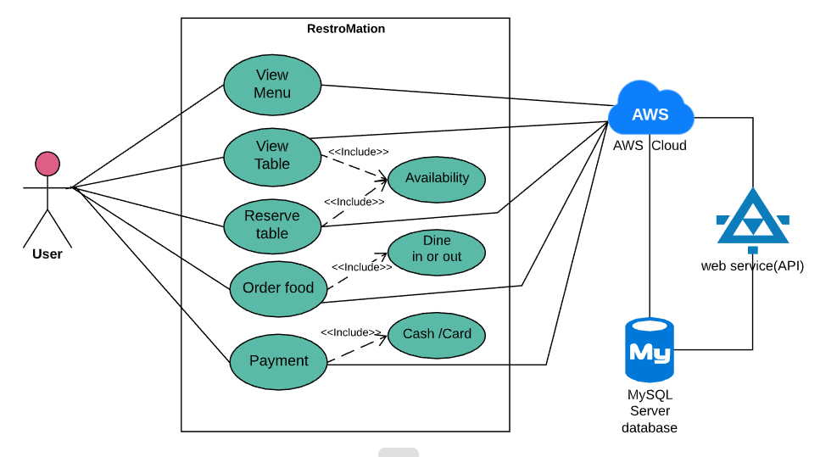

**Fully Dressed use case:**

|  |  |
| --- | --- |
| **Use case section** |  |
| **Use case Name** |  |
| **Scope** |  |
| **Level** |  |
| **Primary Actor** |  |
| **Stakeholder and Interest** |  |
| **Preconditions** |  |
| **Success Guarantee** |  |
| **Main Success Scenario** |  |
| **Extensions** |  |
| **Special requirements** |  |
| **Technology and Variants list** |  |
| **Frequency of occurrence** |  |